OES Project Design Document
Author: Perkins Li
Last Updated: 2017-07-16

Executive Summary if applicable
A short description of what this design document entails. The ‘what’ part of the design is of main interest in this section.
Document History
Date | Author | Summary of Change | Note
17年7月16日 | Perkins Li | Write the documents | None
<Table of Contents>

Overview 4
High Level Architecture 4
Detail Design 4
Class Diagram 4
Sequence Diagram 4
Entities and Relationship 5
Detail Database Schema 6
Table Name01 6
Interface Definitions 6
APIs/Interfaces 7
User Interfaces 7
Error and Exception Handling 7
Other Design Considerations 7

Overview
This section is to describe overall, high level objective of the project.

High Level Architecture
How does this project (or piece of software) fit into the entire system? What role does this project play in relation to the environment in which this project is to function? Again, paying attention to the “what” part of the functionality, what does the overall architecture look like?

Detail Design

Class Diagram
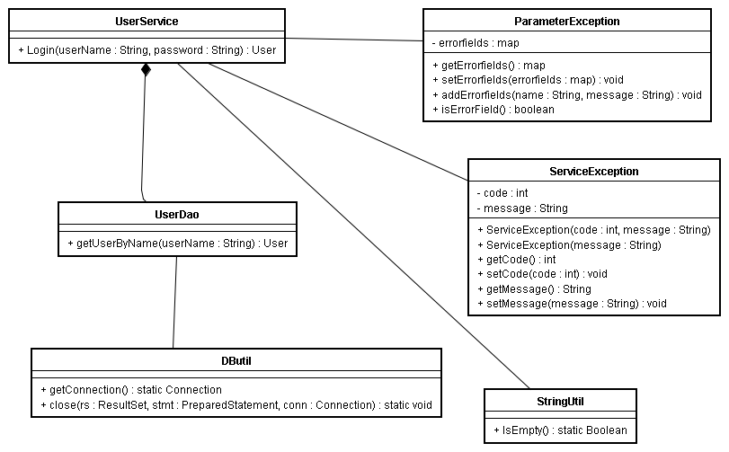

Sequence Diagram

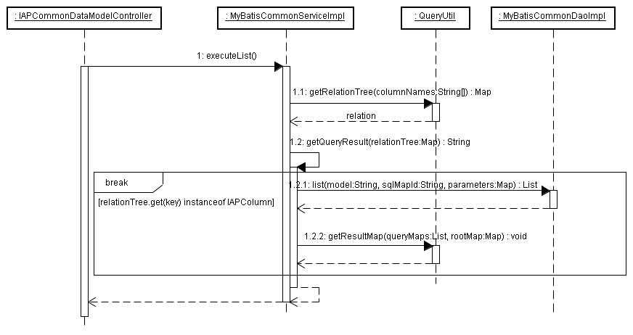

Entities and Relationship

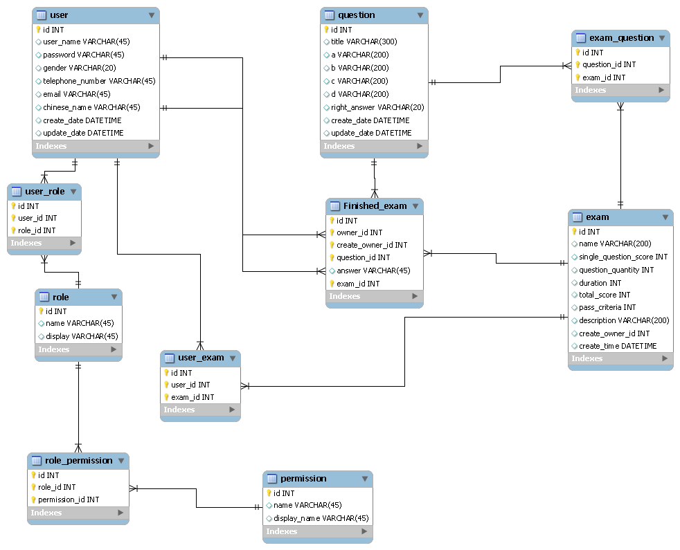

Detail Database Schema

user
Field Name | Data Type | Size | Null? | Comment
id | int | 5 | No | Primary key
user_name | Varchar | 45 | No | User's name
password | Varchar | 45 | No | User's password
gender | Varchar | 20 | No | User's gender
telephone_number | Varchar | 45 | No | User's telephone number
email | Varchar | 45 | No | User's email
chinese_name | Varchar | 45 | Yes
create_date | Datetime |  |  | User was created date
update_date | Datetime |  |  | User information was updated date

role
Field Name | Data Type | Size | Null? | Comment
id | int | 5 | No | Primary key
name | Varchar | 45 | No | Role's name
display | Varchar | 45 | No

user_role
Field Name | Data Type | Size | Null? | Comment
id | int | 5 | No | Primary key
user_id | int | 5 | No | User table's id
role_id | int | 5 | No | Role table's id

permission
Field Name | Data Type | Size | Null? | Comment
id | int | 5 | No | Primary key
name | Varchar | 45 | No | Functional name
display_name | Varchar | 45 | Yes

role_permission
Field Name | Data Type | Size | Null? | Comment
id | int | 5 | No | Primary key
role_id | int | 5 | No | Role table's id
permission_id | int | 5 | No | Permission table's id

exam
Field Name | Data Type | Size | Null? | Comment
id | int | 5 | No | Primary key
name | Varchar | 200 | No | exam's name
single_question_score | int | 45 | No | One of question's score
question_quantity | int | 45 | No | Question's quantity
duration | int | 45 | No | Limit time
total_score | int | 45 | No | Total score
pass_criteria | int | 45 | No
description | Varchar | 200 | Yes
create_owner_id | int | 45 | No
create_time | Datetime |  | No

user_exam
Field Name | Data Type | Size | Null? | Comment
id | int | 45 | No | Primary key
user_id | int | 45 | No
exam_id | int | 45 | No

question
Field Name | Data Type | Size | Null? | Comment
id | int | 5 | No | Primary key
title | Varchar | 300 | No | Question's title
a | Varchar | 200 | No
b | Varchar | 200 | No
c | Varchar | 200 | No
d | Varchar | 200 | No
right_answer | Varchar | 20 | No
create_date | Datetime |  | No
update_date | Datetime

exam_question
Field Name | Data Type | Size | Null? | Comment
id | int | 5 | No | Primary key
question_id | int | 45 | No
exam_id | int | 45 | No

finished_exam
Field Name | Data Type | Size | Null? | Comment
id | int | 45 | No | Primary key
owner_id | int | 45 | No
question_id | int | 45 | No
answer | Varchar | 45 | No
exam_id | int | 45 | No

Interface Definitions

APIs/Interfaces
None.

User Interfaces
None.

Error and Exception Handling
What is the behavior of features under error conditions?
What feedback mechanisms of error condition does the feature have?

In case end users are software developers who are embedding this component, also use this section to identify errors and exceptions that his component generates for the downstream error handling routines.

Other Design Considerations
None.

